Image | 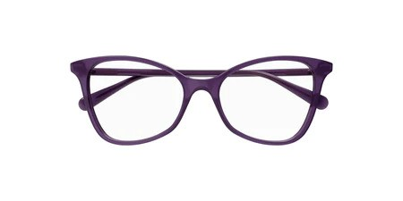
Brand | GUCCI
Model Name | GG 1360O
Price | RS 1699
PRODUCT DETAILS

